

**Team Members:**

|  |  |  |
| --- | --- | --- |
| **ID** | **Name** | **Surname** |
| 040623018 | Ruben | Gjata |
| 040623051 | Baçe | Xhindi |
|  |  |  |

1. **Project Title**

Job Seeker – An Online Platform for Job Applications , Employers seeking workforce

1. **Problem Statement and Motivation**

In the actual job market in Albania, many job-seekers come to face many difficulties to find a concrete workplace. Many companies now days have a dysfunctional and outdated systems for job employment etc., whilst applicants often ought to look on different websites in order to find proper work. Hence, this leads to stress, messy timelines and losing important job opportunities.

The Project “Job Seeker” seeks to solve this problem with offering a unified platform where employers and employees interact with effective way. Users can register according to role they have (as citizens or business) to search, apply and publics jobs in a modern intuitive and interface. This, more than ever, has become important nowadays due to constant digital change, especially relevant for the new generations who look for transparency and effortless methods during the application process, furthermore this platform will simplify employment communication, saving time and improving transparency between users and companies.

1. **Project Objectives**

List 3–5 key objectives that define what you intend to achieve.  
For example:

-To create a web application platform for publishing and application job.

- To securely and clearly separate the work roles (Job Seeker and Employer).

- To implement the management of job advertisements.

-

1. **Proposed Solution**

The “Job seeker” system will be a web MVC application built using ASP.NET Core, which brings forth two types of users: Job Seekers and Employers. Users will be able to register and log into the system, whilst Employers could also publish Job advertisements (Post Job), and job seekers will be able to search and apply for work.

Technologies used: ASP.NET MVC, C#, Entity Framework, SQL, Server, HTML, CSS, Bootstrap.

Awaited result: a web functional application web with a responsive design, ready to expand with Intelligent modules.

1. **Software Development Approach**

The “ Job seeker” Project will follow the “Agile (Scrum)” model, for it is the best method for the development of web based systems whom are tested often and allow continuous adaptation for feedback. This model, hence secures the continuous cooperation between tam members and allows the division of labor in short sprints.

Scrum will assume vital roles such as:

* Product Owner
* Scrum Master
* **Development Team**

The advantages of this method are:

1. The integration of real-time feedback for the user and professor.
2. Making necessary changes without damaging the general structure.
3. The increase of cooperation within the team by using regular meetings (daily stand-ups).
4. The handing of functional periodical versions, which displays the current progress of the project.

In the end of every cycle, the result will bring us a stable, tested and optimized product for the needs of the users – be it jobseekers or employers. This method guarantees the perpetual evolution of the application “Job Seeker”.

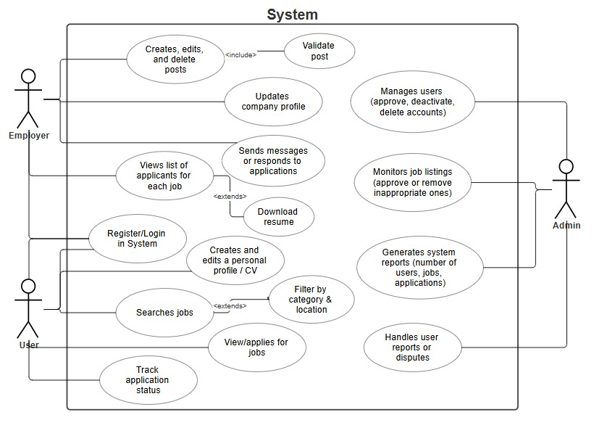

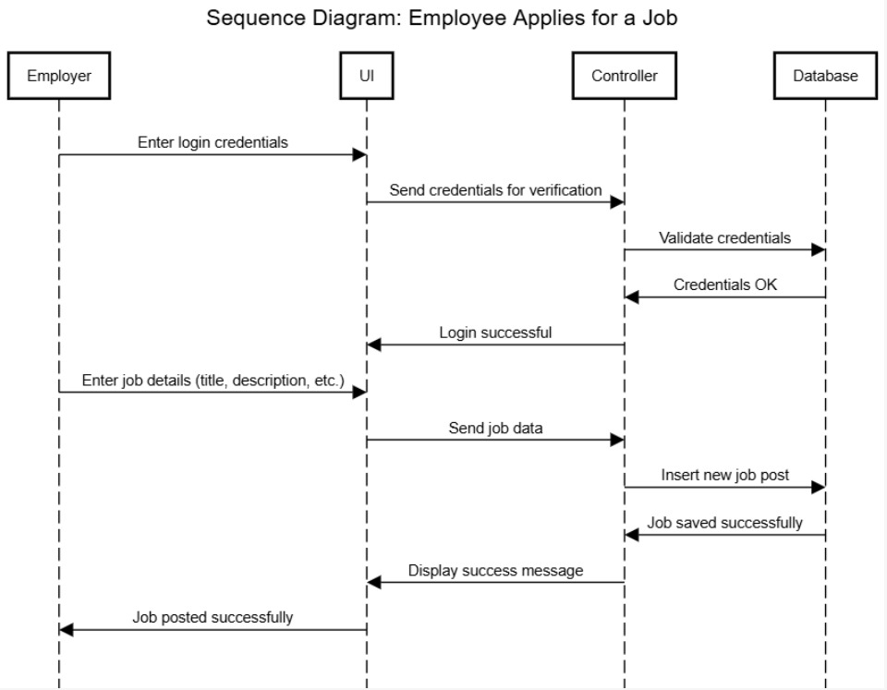

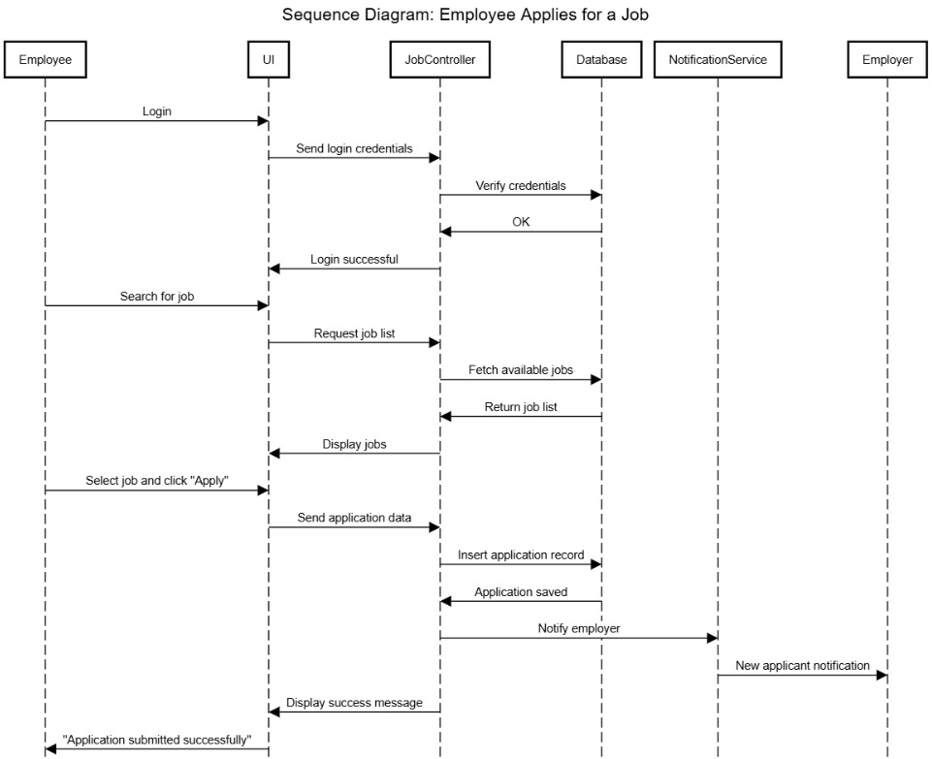

1. **System Architecture Overview**

The system is divided into 3 main levels:

* + 1. Frontend (View Layer): HTML, CSS, Bootstrap for the user Interface.
    2. Backend (Controller & Model): ASP.NET MVC and C# used for business logic.
    3. Database Layer: SQL Server used for data storage (user, work, applications)
    4. Server:

1. **GitHub Repository Setup**

* GitHub Repository URL: https://github.com/Job-Seeker-ProjectSE/JobSeeker

The project will be divided within some primary folders such as:

* /Controllers – for the controllers who manage the application logic (MVC pattern)
* /Models – for models that represent the primary entities like User, Job, Application
* / Views – for the files HTML/CSHTML which are essential for the user interface
* /wwwroot – for static sources
* /Migrations – for managing base versions of information through **ENTITY FRAMEWORK**

Every team member ought to work on a “**feature branch**” dedicated to

After finishing the functionality, the team member ought to make a *pull request* toward the primary sector.

Evry PR will be analyzed from another member of the team for *code review*.

At the end of the sprint, the tested codes will be unified at the primary sector for deployment.

Documentation and management in Git Hub:

* ReadMe.md will contain: the project description, installation instructions, file structures, technologies and instructions for contributions.
* File /docs will contain the UML diagrams, the technical manual
* The *Issues* Section will be used for reporting any mistakes and suggestions
* Milestones will be created for every *sprint* and every task will have labels like bug, enhancement or documentation.

1. **Project Timeline**

|  |  |
| --- | --- |
| Period | Job |
| First arrangements | The creation of the Idea, the design of the sketches and the publication of the project proposal |
| 1st-2nd Week | Creating of the structure MVC and base views (Home, Login, Find Job, Post Job) |
| 3rd-4th Week | Implementing publishing and job searching functions (Controllers), implementing the database and server tests |
| 5th-6th Week | Debug tests |
| 7th Week | The finalization of the project, and the publication in server and in GitHub |

1. **Expected Challenges**

* Management of authentication and authorization for different roles.
* Organization database and its connection with Entity Framework.
* The balance of functionality and easy design for the user.